Lab 4 task 2: Install VMware Tools

You install VMware Tools in the Win10-Tools VM to improve the overall performance of this VM.
----------------------------------------------------------------------------------------------------------
NOTE

You perform the installation using the keyboard because mouse performance is suboptimal without VMware Tools. After VMware Tools is installed in the Win10-Tools VM, mouse performance improves substantially.
----------------------------------------------------------------------------------------------------------

1. Return to the VMware Host Client window.

2. In the right pane, right-click Win10-Tools and select Guest OS > Install VMware Tools.

The VMware Tools ISO image is mounted on the CD/DVD drive of the Win10-Tools VM.

3. Select the Win10-Tools - VMware Remote Console Window.

4. Note the Win10-Tools - VMware Remote Console Window is fully responsive so a mouse could be used to do step (5.) by simply clicking the start icon in the bottom left hand corner of the console.

5. Click anywhere in the console window and press the Tab key to select the Windows Start icon in the lower left corner of the Win10-Tools desktop.

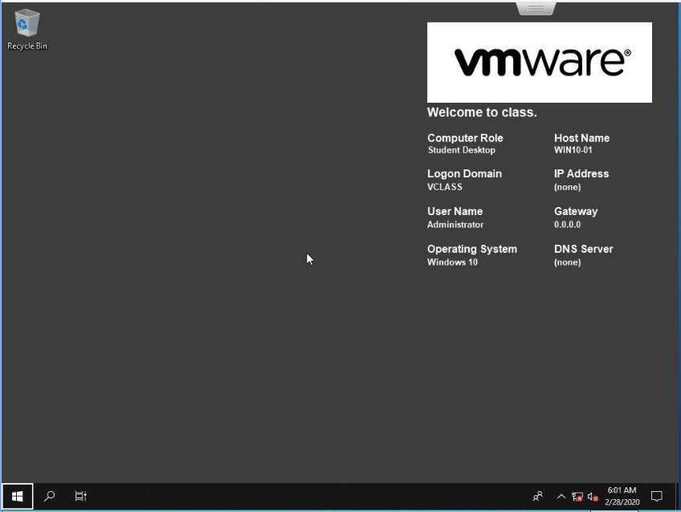

6. After the Windows Start icon is selected, press Enter.

The Windows Start menu opens.

7. Enter D:\ and press Enter.

VMware Tools Setup opens.

8. Install VMware Tools.
- On the Welcome to the instal ation wizard for VMware Tools page, press Enter to select Next.
- On the Choose Setup Type page, verify that Typical is selected.
- Press Tab twice to select Next and press Enter.
- On the Ready to Instal VMware Tools page, press Enter to select Install.
- When the installation is complete, press Enter to select Finish. A window opens requesting that you restart the system.
- Press Enter to select Yes to restart the system.
- Wait for the operating system to reboot. After the reboot is complete, you are automatically logged in as vclass\administrator.

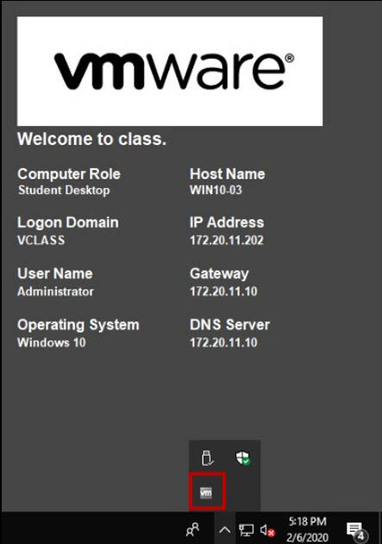

9. Verify that VMware Tools is installed in the VM.
- Using your mouse, navigate to the Windows system tray in the lower right to show hidden icons.
- Double-click the VMware Tools icon.
The window shows the version of VMware Tools and indicates that the VMware Tools service is running.

10. Verify that mouse performance is acceptable.
- Right-click the Windows Start icon and select File Explorer.
- Navigate the folders to verify that mouse performance is acceptable.

11. Close the Win10-Tools - VMware Remote Console Window.

12. Power off the Win10-Tools VM.
- In the right pane of VMware Host Client, right-click Win10-Tools and select Power > Power off.
- Click Yes to confirm the shutdown.
- Verify that the Win10-Tools VM icon indicates that the VM is powered off.

